Software Design Document

-NSW Traffic Penalty Data Analysis Tool-

## GROUP 87

## Anuj Khurana – s5281041

## Puneet - s5296567

## Raghav Kohli - s5326153

Table of Contents

1. System Vision 3

1.1 Background 3

1.2 Software Overview 3

1.3 Potential Benefits 3

2. Requirements 4

2.1 User Requirements 4

2.2 Software Requirements (Functional) 5

2.3 Use Cases 7

3. Software Design and System Components 9

3.1 High-Level Flowchart 9

3.2 Software Components 9

4. User Interface Design 12

4.1 Structural Design (Hierarchy Chart) 12

4.2 Wireframes 12

# 1. System Vision

## 1.1 Background

Road safety and law enforcement are critically dependent on traffic fines and infractions. In New South Wales (NSW), law enforcement authorities gather a lot of information about traffic offences, including specifics about each case, offence codes, locations, and penalties levied. Understanding these trends in traffic, effectively allocating resources, and enhancing road safety all depend on data analysis.

## 1.2 Software Overview

The NSW Traffic Penalty Data Analysis Tool is a software solution designed to give users the power to thoroughly analyse and visualise the vast collection of traffic penalty data in NSW. For obtaining and evaluating this data, this software offers a simple and user-friendly interface.

**The key features of the software include:**

**Data Retrieval**

Users can retrieve penalty case information for specific time periods, allowing for targeted analysis.

**Visualization**

The software generates visualizations such as charts to represent the distribution of cases by offence code, aiding in the identification of prevalent traffic offences.

**Filtering**

Users can filter and view cases captured by radar or camera based on offence descriptions, enhancing the ability to examine specific scenarios.

**Mobile Phone Usage Analysis**

The software allows for an in-depth analysis of cases related to mobile phone usage offences. This includes trend analysis over time and a breakdown of mobile phone usage offences by offence code.

**Penalty Case Reports (Additional Feature)**

Users can generate detailed reports summarizing penalty case information within a selected time. This feature facilitates data review and external reporting.

## 1.3 Potential Benefits

The NSW Traffic Penalty Data Analysis Tool offers several potential benefits:

1. **Improved comprehension of Traffic Offenses**

Law enforcement agencies can gain a deeper understanding of the types and frequencies of traffic offences, enabling informed decision-making.

1. **Improve Resource Allocation**

By identifying prevalent offences, agencies can allocate resources more effectively to target high-risk areas or behaviours.

**3. Knowledgeable Traffic Safety Initiatives**

The software can assist in the development and implementation of road safety initiatives by providing insights into areas requiring intervention.

**4. Accurate Reporting**

The report generation feature simplifies the process of creating detailed penalty case reports for internal use or external reporting, saving time and effort.

**5. Data-Driven Decision-Making**

Users can make data-driven decisions based on trends and patterns identified through analysis and visualization.

**6. Generate Greater Awareness**

The tool raises awareness about specific traffic offences and their consequences, promoting safer driving behaviours.

In conclusion, the NSW Traffic Penalty Data Analysis Tool intends to use data analytics and visualisation to improve resource allocation, advance efforts to increase road safety, and offer insightful information to law enforcement organisations and policymakers in NSW.

# 2. Requirements

## 2.1 User Requirements

1. **Select a Period to View Penalty Case Information**

* **User Interaction:** Users should be able to select a specific time frame during which they want to access information about penalty cases. An input method similar to a date picker might be used to do this.
* **Goal:** By allowing users to concentrate on penalty instances within a given time window, this tool enables users to examine trends and patterns throughout particular time frames.

2. **Generate Charts to Visualize Offense Code Distribution**

* **User Interaction:** Users should be able to start the creation of graphs that show how punishment cases are distributed by offence code. To do this, you might need to click the "Generate Chart" option.
* **Goal:** By making it easy for users to understand how various offence codes are distributed, visualisations help identify common or serious infractions.

3. **Filter and View Cases Captured by Radar or Camera Based on Offense Description**

* **User Interaction:** Users should be able to enter a description of the offence (such as "speeding") and apply a filter to view only those instances where the infraction was detected by radar or camera and matched the description. Through a search bar or filter choices, one may accomplish this.
* **Goal:** Filtering by crime description enables users to concentrate on a small subset of offences, which is helpful for analysis and reporting.

4. **Analyze Cases Related to Mobile Phone Usage Offenses with Trend Analysis**

* **User Interaction:** • User Interaction: Users ought to be able to start the investigation of cases involving mobile phone violations. This could entail selecting a particular analysis parameter, such as a time frame, or pressing the "Analyse" button.
* **Purpose:** Mobile phone offences are a major worry; therefore this is why. Users can determine variations in these offences over time and see whether enforcement efforts are successful by using trend analysis.

## 2.2 Software Requirements (Functional)

1. **Load and Pre-process the NSW Traffic Penalty Data**

* **Functionality:** The programme must be able to import the NSW Traffic Penalty Data from a data source, clean it by managing missing data and removing duplicates, and pre-process it to ensure that it is in a format that can be used for analysis.
* **Goal:** Clear and organised data are necessary for precise analysis and visualisation.

2. **Provide an Interactive Graphical User Interface (GUI)**

* **Functionality:** The programme should have an easy-to-use GUI that enables seamless user interaction with the tool. Date pickers, buttons, search bars, and chart displays should all be included**.**
* **Goal:** A user-friendly interface facilitates task completion and helps users draw conclusions from the data.

3. **Retrieve Penalty Case Information Based on User-Selected Time Periods**

* **Functionality:** Users should be able to choose specified time frames, and the programme should retrieve and show information on penalty cases for that time frame.
* **Goal:** With the help of this function, users can access the pertinent data for analysis and concentrate on a specific timeframe**.**

4. **Generate Charts for Offense Code Distribution Analysis**

* **Functionality:** The programme should be able to provide graphs that show how punishment cases are distributed according to the crime code. For this, it ought to make use of charting tools or libraries.
* **Goal:** By visualising the distribution of offence codes, users can more easily determine which offences are most common.

5. **Filter and Display Cases Captured by Radar or Camera Based on User-Provided Offense Descriptions**

* **Functionality:** Users should be able to enter descriptions of offences, and the software should filter the dataset to only show instances that correspond to the descriptions**.**
* **Goal:** Investigating specific offences is made possible by using the offence description filter, which enhances data analysis capabilities**.**

6. **Perform Mobile Phone Usage Offense Analysis, Including Trend Analysis and Offense Code Breakdown**

* **Functionality:** The programme should analyse historical trends in mobile phone usage offences and provide breakdowns of the various offence codes. It should employ the proper algorithms for data aggregation and analysis**.**
* **Goal:** By identifying the precise codes connected to these offences, this tool aids users in understanding the patterns in mobile phone usage offences.

These elaborated requirements provide a clear understanding of how users will interact with the software and what functionality the software should deliver to meet their needs effectively.

## 2.3 Use Cases

### Use Case 1: Retrieve Penalty Case Information

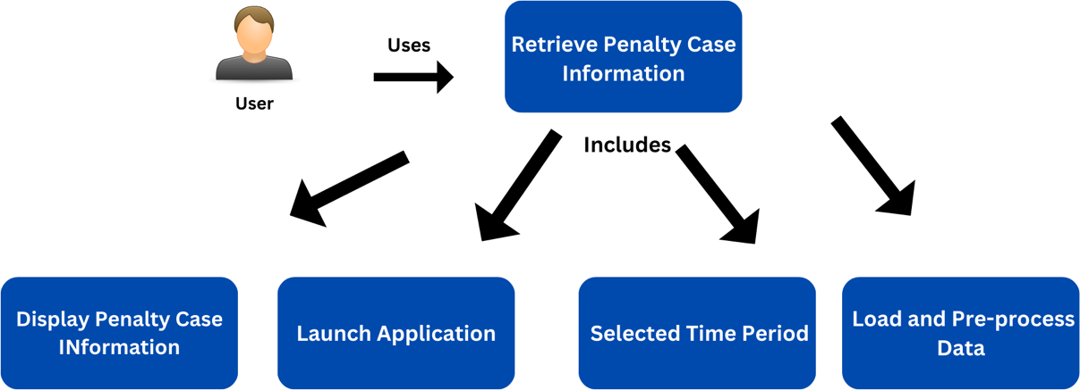

**Actor:** User

**Description:** The user would like to access the number of cases that have been classified by the offence code during a particular period of time.

**Steps:**

1. The user launches the application.
2. The user selects the "Retrieve Penalty Case Information" option.
3. The user chooses a time period (start and end dates).
4. The software loads and pre-processes the data for the selected time period.
5. The software displays the penalty case information, including offence codes, dates, locations, and penalties.

### Use Case 2: Visualize Offense Code Distribution

**Actor:** User

**Description:** The user wants to see how many cases fall under each offence code during a given time period.

**Steps:**

1. The user launches the application.
2. The user selects the "Visualize Offense Code Distribution" option.
3. The user chooses a time period (start and end dates).
4. The software generates a chart displaying the distribution of cases in each offence code for the selected period.
5. The chart is displayed in the application's interface.

### Use Case 3: Filter Cases by Offense Description

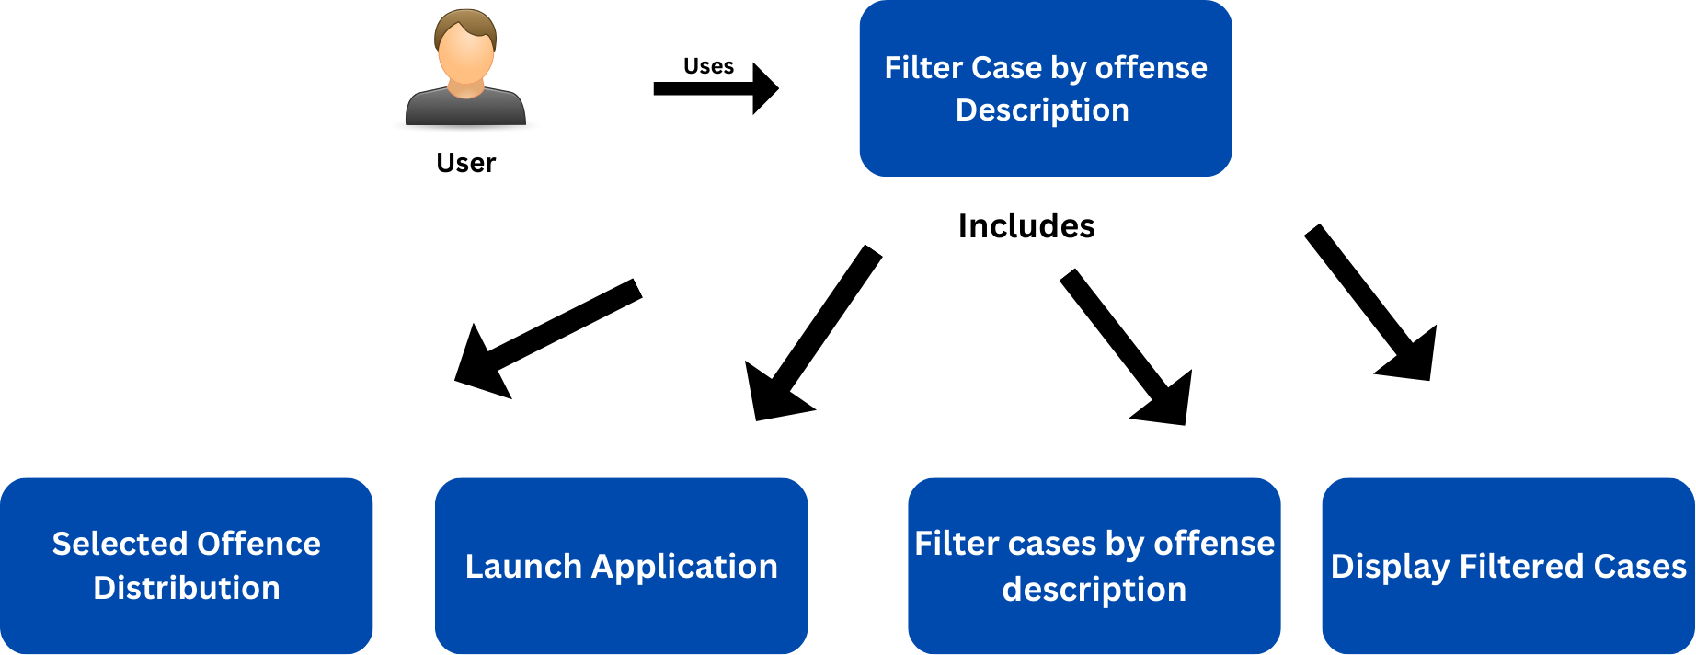

**Actor:** User

**Description:** The user is seeking to sort and examine incidents detected by radar or camera that match a particular offence description.

**Steps:**

1. The user launches the application.
2. The user selects the "Filter Cases by Offense Description" option.
3. The user enters an offence description in a text field.
4. The software filters the dataset to find cases matching the provided description.
5. The software displays a list of cases captured by radar or camera that match the offence description.

### Use Case 4: Analyze Mobile Phone Usage Offenses

**Actor:** User

**Description:** The individual desires to inspect violations related to the usage of mobile phones, including analysing trends and breaking down the codes of such offences.

**Steps:**

1. The user launches the application.
2. The user selects the "Analyze Mobile Phone Usage Offenses" option.
3. The user chooses a time period (start and end dates).
4. The software performs trend analysis on mobile phone usage offences over the selected time period.
5. The software displays trend analysis charts and statistics.
6. The software provides a breakdown of mobile phone usage offences by offence code.

### Use Case 5: Generate Penalty Case Reports (Additional Feature)

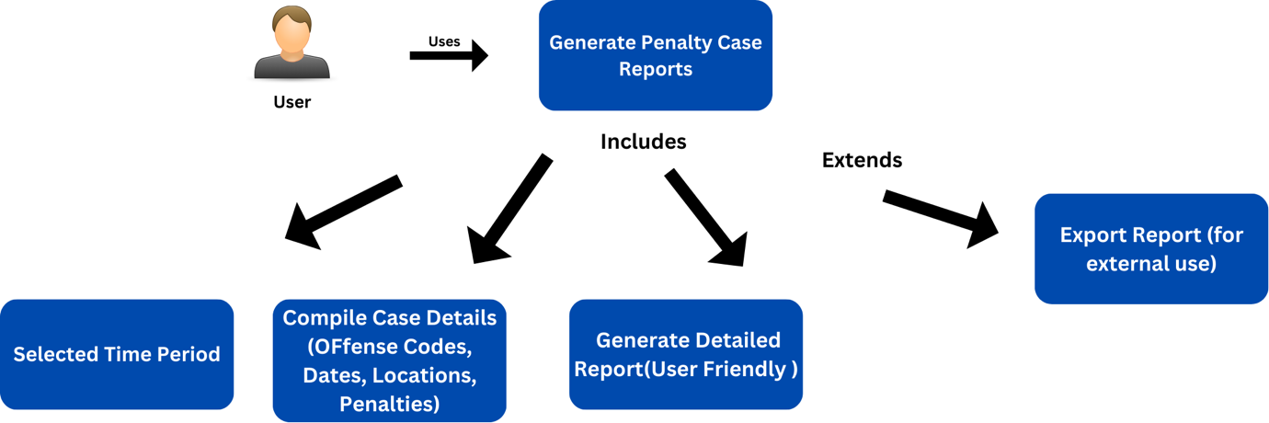

**Actor:** User

**Description:** The user is seeking to compile a report that encompasses specific penalty cases within a designated time period.

**Steps:**

1. The user launches the application.
2. The user selects the "Generate Penalty Case Reports" option.
3. The user chooses a time period (start and end dates).
4. The software compiles case details such as offence codes, dates, locations, and penalties for the selected time period.
5. The software generates a detailed report in a user-friendly format.
6. The user can view and analyze the report within the application or export it for external use.

These use cases outline how users will interact with the NSW Traffic Penalty Data Analysis Tool to perform various tasks, including data retrieval, visualization, filtering, analysis, and report generation.

# 3. Software Design and System Components

## 3.1 High-Level Flowchart

A high-level overview of the user's interactions with the GUI and the subsequent data processing and display phases is provided by this flowchart. This will be beneficial for the software's real implementation and debugging.

The general flow of the software can be summed up as follows:

Users interact with the GUI to choose from a variety of options, and the software then calls the appropriate routines to retrieve and process the user's chosen options.

• Charts, reports, or filtered case listings are used to display data.

• Users can create reports as needed, view distributions, and analyse trends.

A future addition of new features and analysis capabilities is made possible by the software's modular and expandable design.

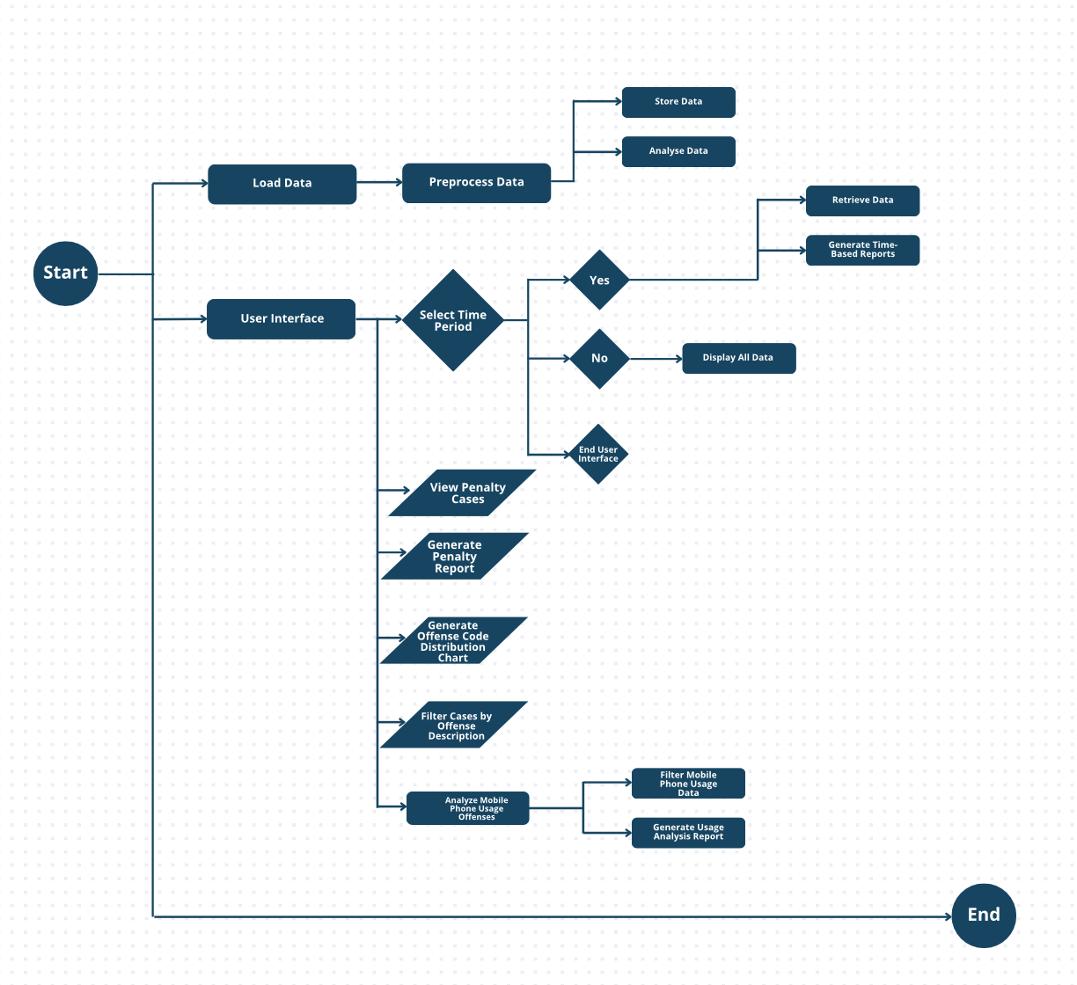

## 3.2 Software Components

1. **Load Data**

* **Type: Function**
* Details: The loading and preliminary processing of the NSW Traffic Penalty Data are the responsibilities of this function. It reads the dataset, cleans the data, and then gets it ready for analysis.

2. **GUI Module**

* **Type: Module**
* Details: The GUI module contains classes and functions for the graphical user interface. It includes the following components:
  + Main Application Window: The main window that houses all interface components.
  + Date Selection Widget: Allows users to select a time period.
  + Buttons and Menus: Provide options for different features.
  + Chart Display Area: Displays charts and visualizations.
  + Input Forms: For entering offence descriptions or other user inputs.

3. **Retrieve Data**

* **Type: Function**
* Details: This function retrieves penalty case information based on the user-selected time. It interfaces with the dataset and extracts relevant data within the specified date range.

4. **Chart Module**

* **Type: Function**
* Details: The Chart Module function is responsible for generating charts to visualize data. It includes the following sub-functions:
  + **Generate-OffenseCode-DistributionChart**: Creates a chart showing the distribution of cases in each offence code for the selected period.
  + **Generate-Report**: Generates report on penalty case analysis for reporting.

5. **Filter Data**

* **Type: Function**
* Details: This function filters and displays cases captured by radar or camera based on user-provided offence descriptions. It allows users to enter specific offence descriptions and retrieves matching cases from the dataset.

6. **Mobile Usage Analysis**

* **Type: Function**
* Details: The Mobile-Usage-Analysis function is responsible for analyzing cases related to mobile phone usage offences. It includes the following sub-functions:
  + **Mobile-Trend-Analysis**: Analyzes trends in mobile phone usage offences over time.
  + **Offense-Code-Breakdown**: Provides a breakdown of mobile phone usage offences by offence code.

**7. Data Structures**

* **Type: Data Structures (e.g., Lists, Dictionaries)**
* Details: Data structures are used to store and manipulate data throughout the software. For example, lists may be used to store retrieved data, and dictionaries may be used for offence code information.

**8**. **Algorithms**

* **Type: Various Algorithms**
* Details: Several algorithms will be employed for data pre-processing, chart generation, and analysis. These may include:
  + Data Cleaning Algorithms: To handle missing or inconsistent data.
  + Charting Algorithms: For creating visualizations.
  + Filtering Algorithms: To filter data based on user-provided criteria.
  + Report Generate Algorithms: To identify trends over time.

**Additional Feature: Reporting Penalty Case Information**

This additional feature will include a new function and interface component:

9. **Report Penalty Cases**

* **Type: Function**
* Details: This function generates a report of penalty case information for a user-selected period. It compiles case details such as offence codes, dates, locations, and penalties and generates a report in a user-friendly format, which can be displayed in the GUI or exported.

# 4. User Interface Design

This user interface design strives to give consumers a fluid and simple experience so they can interact with the software effectively and carry out the necessary functions:

1. Retrieve data about penalty cases for a time frame chosen by the user.

2. Create graphs to show the distribution of offence codes' cases.

3. Use the offence description to filter and see cases that were detected by radar or camera.

4. Examine incidents brought on by mobile phone use, considering historical trends and the breakdown of offence codes.

5. Generate external reports for penalty cases.

## 4.1 Structural Design (Hierarchy Chart)

The NSW Traffic Penalty Data Analysis Tool's user interface (UI) will be created to make it simple to access the necessary features and functions. Here is the UI's structural architecture, including the primary screens and components and how they relate to one another:

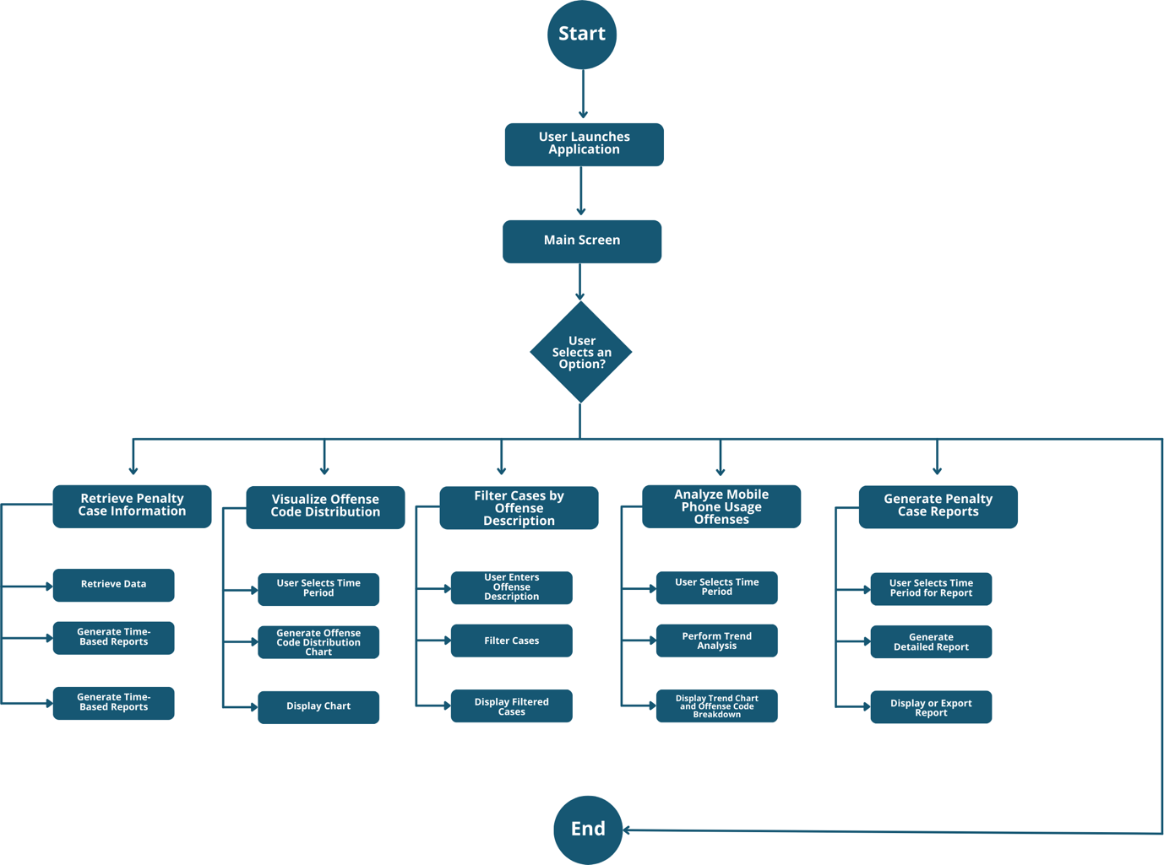

## 4.2 Wireframes

These wireframes show how the extra capability for producing penalty case reports would be incorporated into the software's user interface. Users can generate reports, view case facts in an organised fashion, and choose a date period with ease to retrieve data.

### 1. Information Display Area (Main Screen)

The tool will open on the main screen with a navigation menu on the side and a Date Range selector with data in the centre. This is the information Display area screen. The information includes columns for case details such as offence codes, dates, locations, and penalties.

* **Purpose**: Landing page where users can access various features.
* **Components**:
  + Date Range Selector: Allows users to select the time period of interest.
  + Navigation Menu: Provides quick access to different features.
    - "Penalty Cases": Access penalty case information.
    - "Offense Code Distribution": Generate charts for offence code distribution.
    - "Radar/Camera Cases": Filter cases based on offence description.
    - "Mobile Usage Analysis": Perform trend analysis for mobile phone usage offences.
  + Information Display Area: Displays the information results of the selected date or type.

### 2. Penalty Cases Screen

* **Purpose**: Display detailed information about penalty cases within the selected period.
* **Components**:
  + Date Range Selector: Allows users to select the period of interest.
  + Data Table: Tabulated view of penalty cases.
  + Export Button: Option to export the data for further analysis.
  + Generate Report Button: Users can click on this option to access the report generation feature for penalty cases. (Additional feature)
  + Navbar: Navigation Menu with the back button.

### 3. Offense Code Distribution Screen;

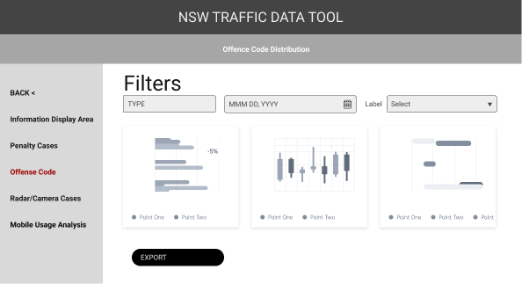

* **Purpose**: Visualize the distribution of cases by offence code.
* **Components**:
  + Chart Display: Area to show the chart illustrating offence code distribution.
  + Export Button: Option to export the chart for reporting.
  + Navbar: Navigation Menu with the back button.

### 4. Radar/Camera Cases Screen;

* **Purpose**: Allow users to filter and view cases captured by radar or camera based on offence description.
* **Components**:
  + Offence Description Input: Text box for entering an offence description.
  + Filter Button: Trigger the filtering process.
  + Results Table: Display filtered cases.
  + Navbar: Navigation Menu with the back button.

### 5. Mobile Usage Analysis Screen

* **Purpose**: Analyze cases related to mobile phone usage offences, including trend analysis and offence code breakdown.
* **Components**:
  + Trend Chart: Display the trend of mobile phone usage offences over time.
  + Offence Code Breakdown Chart: Show the breakdown of offences by code.
  + Export Button: Option to export charts and statistics.
  + Navbar: Navigation Menu with the back button.

### 6. Report Generation Interface Screen

* **Purpose:** In the report generation interface, users are prompted to select a time period for which they want to generate a report. They can choose a start and end date. Once the report is generated, it is displayed in a structured format.
* **Components:**
* There is a "Generate Report" button that initiates the report generation process.
* Below the date selection, there is space for displaying the generated report.
* Users can scroll through the report to view all penalty cases within the selected period.
* There may be options to customize the report format or export it to formats like PDF or IMG.

### Additional Design Details

• Navigation: A sidebar that displays all tool features (screen) buttons for simple navigation.

• Consistency: Keep the interface's fonts, colour schemes, and styling the same across the board.

• Error handling: Use error notifications and messages to direct users in the event of input errors or problems.

• Accessibility: When designing, keep accessibility in mind. This includes including alternative language for images and enabling keyboard navigation.